

What is Github?
Github is an online cloud-based platform where people store, share, and work together on computer code.
What is Git?
Git is a free, open-source distributed Version Control System designed to track changes in source code and files over time.

Github uses a system called Git to track every change made to a file

STEP 0: Create your account on Github
STEP 1: Installing Git
Link: https://git-scm.com/install/windows
STEP 2: REMOVE Github Credentials (if required)
- Search on Taskbar Credential Manager and Open it
- Goto Windows Credential
- In Generic Credential, check git:https://github.com and Remove it
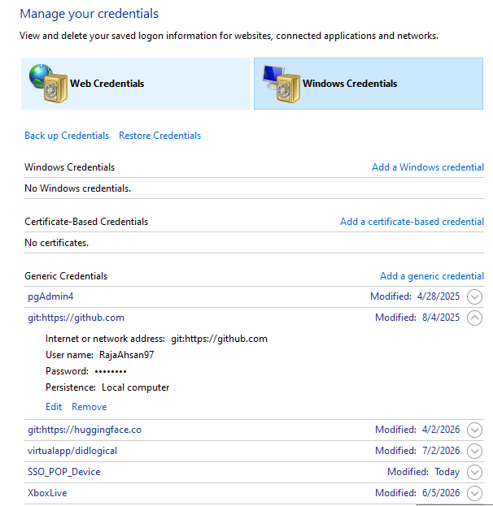

STEP 3: Git CONFIGURATION on Local Machine
- Open command window
- Check Git version using command
>> git –version
- Configure your username locally
>> git config --global user.name "<github user name should be there>"
- Configure your email locally
>> git config --global user.email "<your email of github>"
- Close the command window
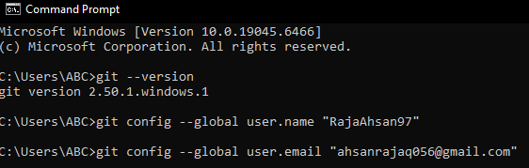
STEP 4: VALIDATE above CONFIGURATIONs
- Open command window
- >> git config --global user.name
- >> git config --global user.email
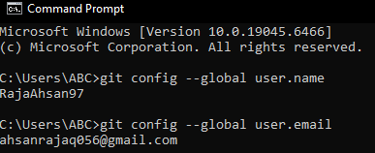
STEP 5: CREATE a new Repository on GIthub
STEP 6: Open your folder and create file or jupyter notebook
STEP 7: OPEN command prompt from your folder and RUN these commands
- git init (initalize/reinitalize the git in your folder)
- git status (shows all untracked files)
- git add . ( to add file/files changes to be committed)
- git commit -m "first commit" ( commit those added file/files using git add command)
- git branch -M main (rename the branch to "main" from "master")
- git remote add origin <your-repo-url>
- git push -u origin main
STEP 8: PUSH an existing repository from command line
- git add .
- git commit –m “Describe your changes”
- git push origin main

